**Machine Learning**

**AREEBA MARIUM**

**Email:areebamarium43@gmail.com**

**TASK 1:**

**MUSIC RECOMMDATION SYSTEM:**

Spotify's recommendation system, powered by machinelearning, predicts a user's likelihood of repeatedly listening to asong within a set timeframe. Using a dataset with 1 indicatingrepeated plays within a month, it tracks user song histories andtimestamps to generate personalized song recommendation

**CODE:**

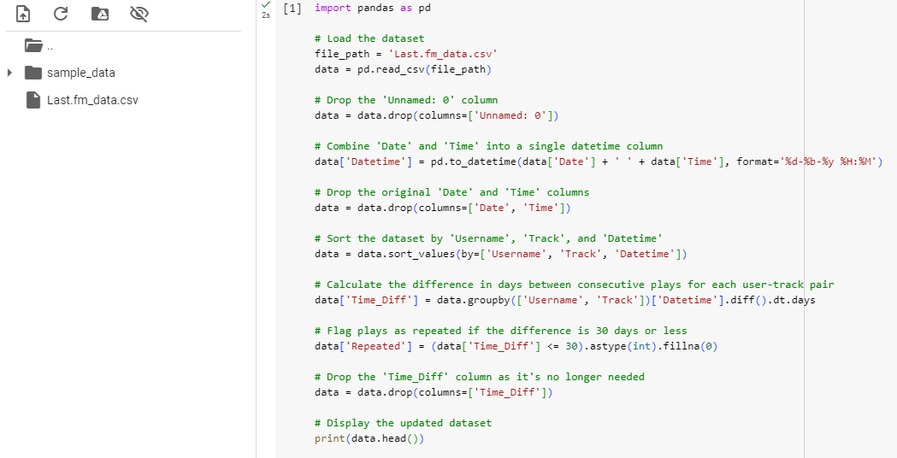

**OUTPUT:**

